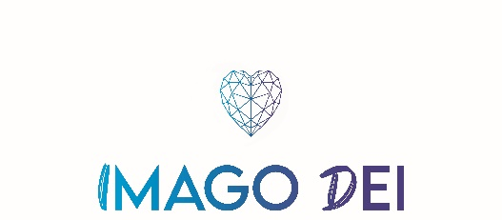

Gift Aid Form

MAILING LIST
Please add my details of to your mailing list. I would like to receive your monthly email update.

CONTACT DETAILS

TITLE ............... FORENAME(S) ............................................. SURNAME .....................................................

ADDRESS ........................................................................................................................................................

.................................................................................................................POSTCODE ....................................

TELEPHONE NO ............................................EMAIL ADDRESS ...................................................................

ONE-OFF DONATION
I/We would like to support Imago Dei Prison Ministry and enclose our gift of £ ..................................

GIFT AID DECLARATION
I am a UK tax payer and understand that if I pay less Income Tax and/or Capital Gains Tax in the current tax year than the amount of Gift Aid claimed on all my donations it is my responsibility to pay any difference. I understand Imago Dei Prison Ministry will reclaim 25p for every £1 I have given and I would like Imago Dei Prison Ministry to treat all the donations I have made as well as any future donations as Gift Aid until I notify them otherwise.

Signed…………………………………………. Date …………………………………….

PLEASE RETURN THIS FORM TO:
Imago Dei Prison Ministry, PO Box 830, East Grinstead, RH19 9GU
fundraising@idprisonministry.org.uk Charity Reg No: 1165176

